SETUP DUAL GITHUB LOGIN ACCOUNT

- Go to the folder location: C:\Users\Sumit Mondal\.ssh

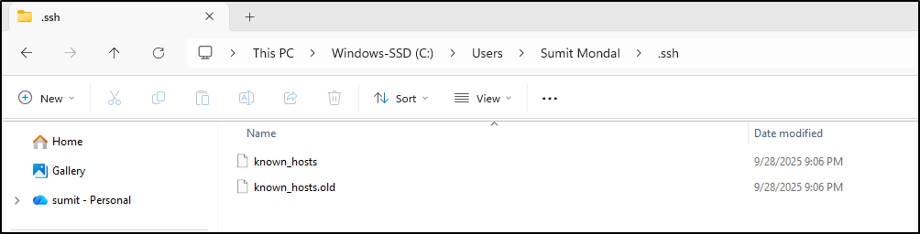

- Run the command to generate SSH Key: (Github Account 1: ssh-keygen -t ed25519 -C hiisumit2u@gmail.com)
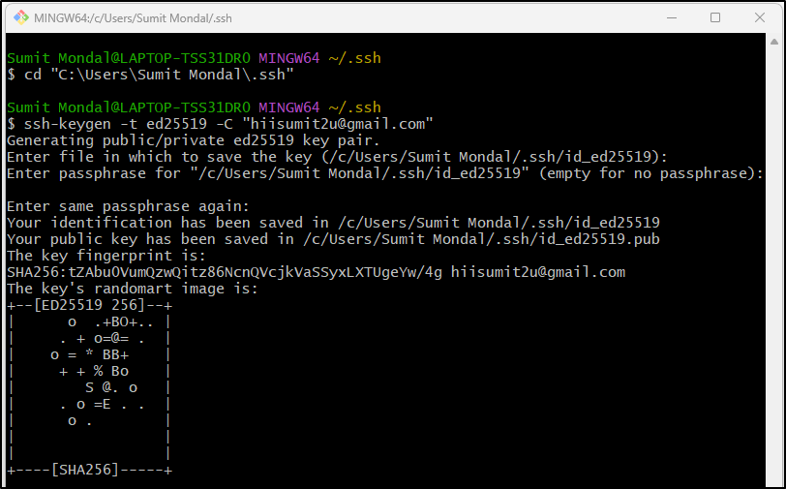
Note: rename the file from id_ed25519 to id_hiisumit.pub; id_hiisumit

- Run the command to generate SSH Key: (Github Account 2: ssh-keygen -t ed25519 -C "hanusm2123@gmail.com")
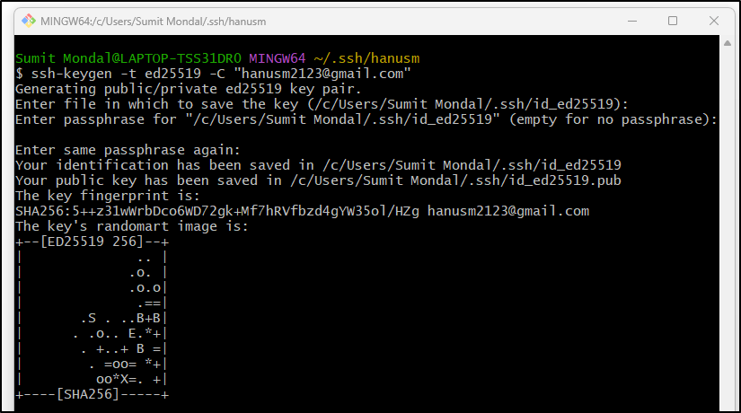
Note: rename the file from id_ed25519 to id_hanusm.pub; id_hanusm

- Check shh-agent is running: (Command: eval "$(ssh-agent -s)")
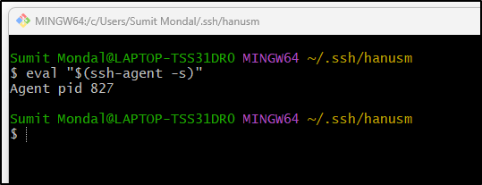

- Setup the SSH key with both GITHUB account:

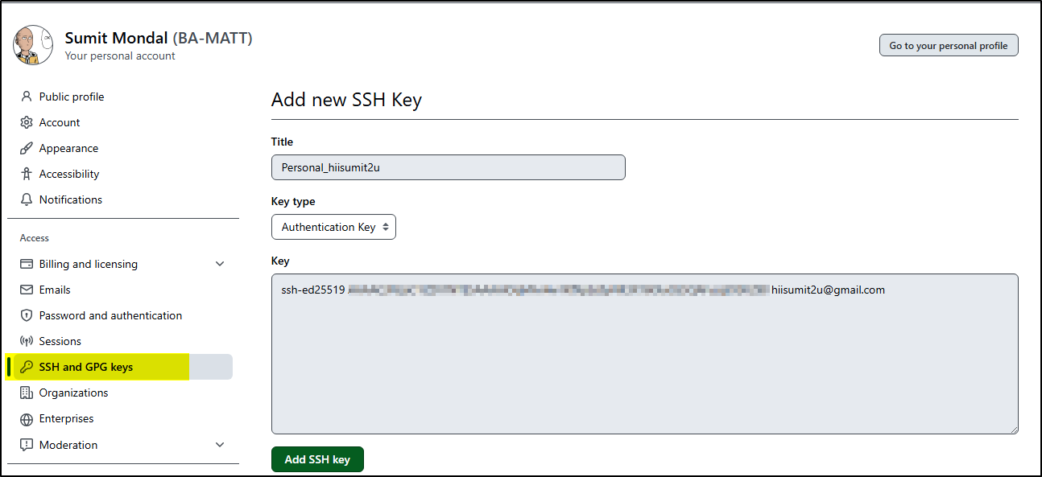
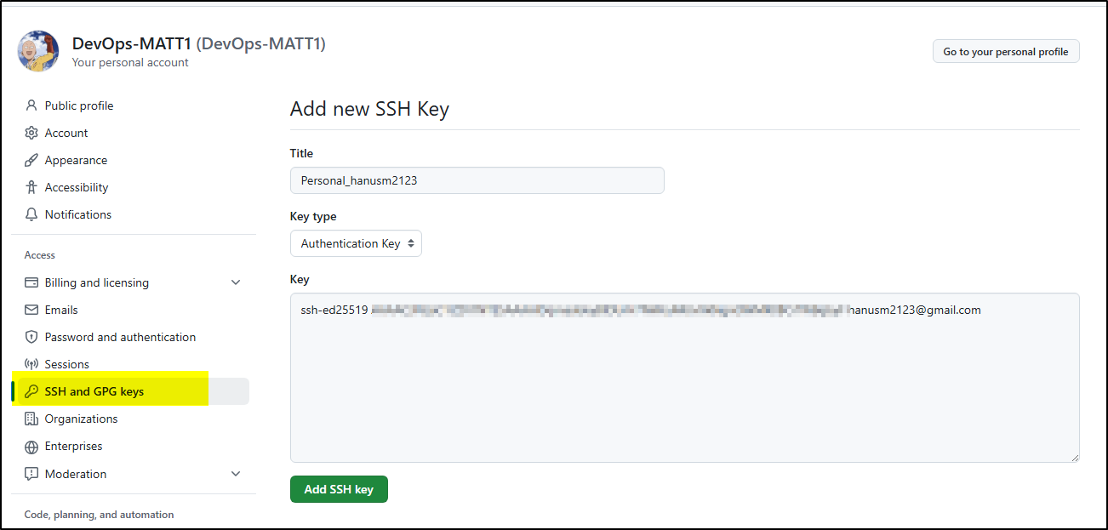

6. Add detail to config file (Note: Save the file and do not put any file extension)

Config file Details:
===============================
# 1️. First account (hiisum2u@gmail.com)
# ===============================
Host github-BAMATT
HostName github.com
User git
IdentityFile "C:/Users/Sumit Mondal/.ssh/id_hiisumit"
IdentitiesOnly yes

# ===============================
# 2️. Second account (hanusm2123@gmail.com)
# ===============================
Host github-DevOpsMATT1
HostName github.com
User git
IdentityFile "C:/Users/Sumit Mondal/.ssh/id_hanusm"
IdentitiesOnly yes

- Add ssh key and validate the config file

Add key:
- ssh-add id_hanusu
- ssh-add id_hiisumit

Validate SSH setup:
- ssh -T git@github-BAMATT
- ssh -T git@github-DevOpsMATT1

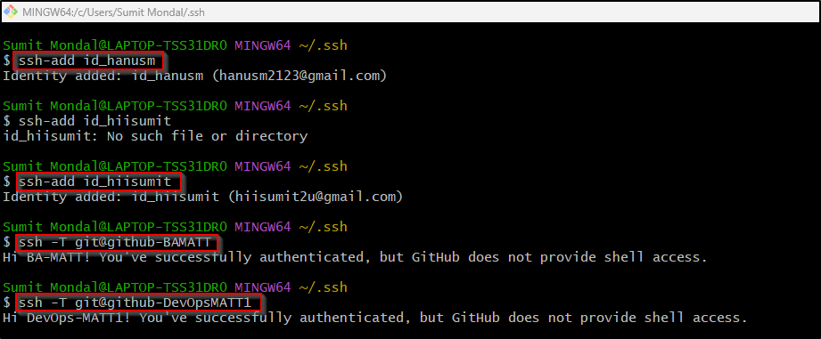

- Other commands
#List all SSH Key
ssh-add -l

#Delete all SSH Key:
ssh-add -D

- Now you can do clone using:

Ex:
- git clone git@github-DevOpsMATT1: DevOps-MATT1/GitFetchPull-Exercise.git
- git clone git@github-BAMATT: DevOps-MATT1/Exercise1.git
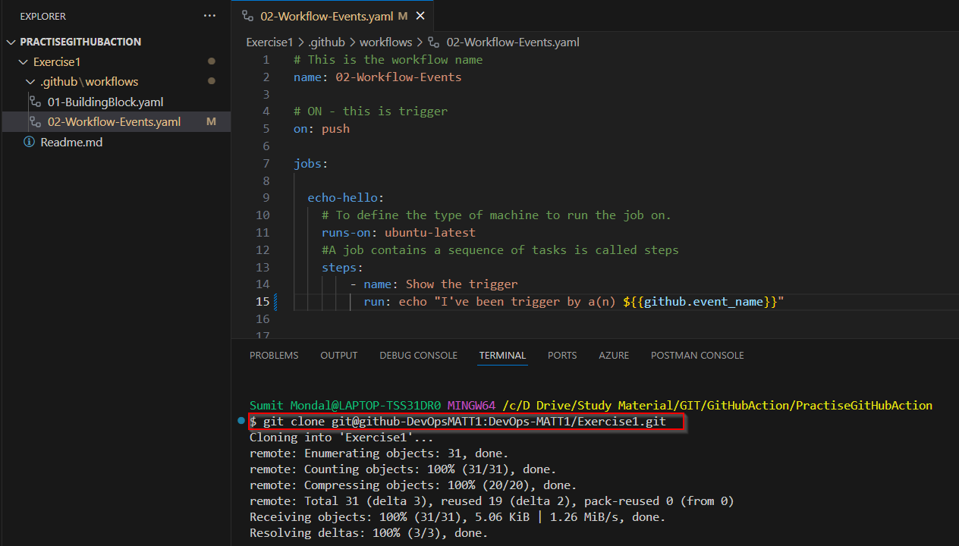
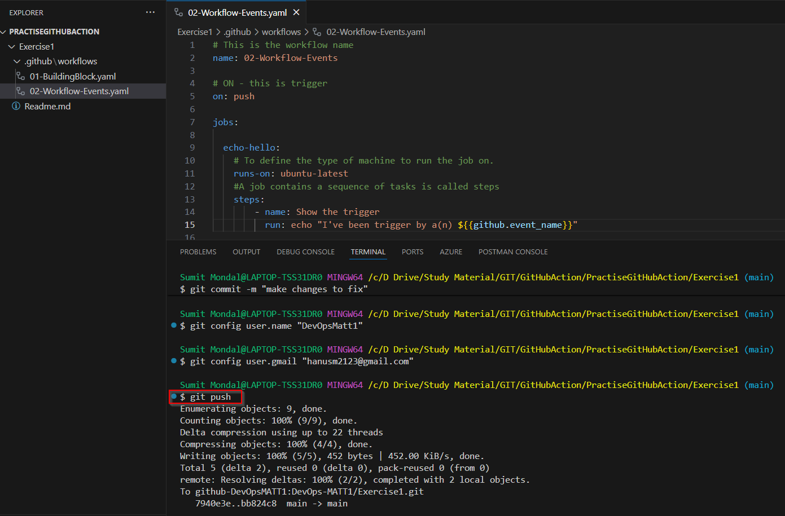
Reference YouTube Video: https://www.youtube.com/watch?v=cm68GCEcBXU

